

CS3219: Project Milestone 1 (D1)
ProjectGroup 30
No. | Full Name (as in EduRec) | Student Number (Axxxx)
1 | Jonus Ho Zhi Wen | A0272520N
2 | Patrick Thomas | A0273834X
3 | Isaac Chua Qian Xiang | A0269802X
4 | Zhang Yuan | A0272953W
5 | Anselm Pius Long | A0273055H

Product Backlog

Functional Requirements

User Service
User Service |  |  | Priority | Planned  iteration
ID | Parent | Requirement | Priority | Iteration
US-FR1 |  | The User Service shall provide authenticated student account access. | Must | I1
US-FR1.1 | US-FR1 | The service shall manage registration, activation, login, and logout for one account per unique campus email. | Must | I1
US-FR1.1.1 | US-FR1.1 | Registration shall treat email addresses that differ only in letter case or surrounding spaces as the same, refuse an address outside the NUS email domains the platform is configured to allow, and refuse an address that is already registered, without creating an account. | Must | I1
US-FR1.1.2 | US-FR1.1 | Only an account with valid credentials shall be signed in, for a session of at most seven days; logging out shall end the current session. | Must | I1
US-FR2 |  | The User Service shall enforce role-based access control. | Must | I1
US-FR2.1 | US-FR2 | The service shall distinguish student and administrator roles, and every active student shall be able to act as both requester and courier. | Must | I1
US-FR2.1.1 | US-FR2.1 | An active student shall be able to act as requester and as courier without a second account or a change of role by an administrator. | Must | I1
US-FR2.1.2 | US-FR2.1 | The platform shall make every permission decision for a user's action itself; a displayed value, or a role or identity claimed by the user's device, shall never decide what a user may do. | Must | I1
US-FR3 |  | The User Service shall manage profiles and account status. | Must | I1
US-FR3.1 | US-FR3 | The service shall separate student-editable profile fields from administrator-controlled identity and status fields. | Must | I1
US-FR3.1.1 | US-FR3.1 | A student shall be able to view and update only their own display name, faculty, profile picture, contact preference, and preferred mode, and an update that tries to change a role, account status, identifier, or email shall be refused; an administrator may view any user's profile but not edit it, and only an administrator shall be able to change a user's account status. | Must | I1
US-FR3.1.2 | US-FR3.1 | An administrator may suspend or reactivate an account with a reason; a suspended account shall be denied new sign-ins and new errand actions, while the account's own history remains available to administrators. | Must | I1
US-FR3.1.2.1 | US-FR3.1.2 | A user who is not an administrator shall not be permitted to perform any action on another user's account, including by putting another account's identifier in a request. | Must | I1
US-FR3.1.2.2 | US-FR3.1.2 | No account shall be deleted; an account that should no longer be used shall be suspended instead, so that every errand, credit entry, and audit record still resolves to the account it concerns. | Must | I1
US-FR3.1.3 | US-FR3.1 | The service shall control how administrators are created, appointed, and removed, so that at least one active administrator exists at all times. | Must | I1
US-FR3.1.3.1 | US-FR3.1.3 | Only a bootstrap administrator (US-FR3.1.3.2) may remove another administrator's role or suspend another administrator; no administrator may remove their own role or suspend themselves, and a change that would leave no active administrator shall be refused. | Must | I1
US-FR3.1.3.2 | US-FR3.1.3 | The first administrators (bootstrap administrators) shall be created from deployment configuration through the service's normal account provisioning, never by a direct database change. Running the bootstrap again, or twice at once, shall create no further accounts; each run shall be recorded in the audit trail without its secret; and no secret from the configuration shall remain usable after the administrator's first sign-in. | Must | I1
US-FR3.1.3.3 | US-FR3.1.3 | An administrator shall be able to appoint an active student as an administrator, with a reason, without any developer involvement. | Must | I1
US-FR4 |  | The User Service shall expose identity state to other services without exposing credentials. | Must | I1
US-FR4.1 | US-FR4 | The service shall tell other services about account changes and let them look up only the account information they need. | Must | I1
US-FR4.1.1 | US-FR4.1 | After a student's first activation, the service shall tell the Credit Service, so that the new account receives its initial credits. | Must | I1
US-FR4.1.2 | US-FR4.1 | A lookup by another verified platform service shall return only whether the account exists, its status, its roles, and its display name, and shall never return passwords, stored password values, or security tokens. | Must | I1
US-FR4.1.3 | US-FR4.1 | The service shall expose a user's effective permissions to any service that requires administrator authorization before carrying out an action. | Must | I1
US-FR4.1.4 | US-FR4.1 | When an account is suspended or reactivated, the service shall tell dependent services which account changed, its new status, the reason, and when it happened, so that they can act on the change within 10 seconds. | Must | I1

Supplier Service
Supplier Service |  |  | Priority | Planned  iteration
ID | Parent | Requirement | Priority | Iteration
SS-FR1 |  | The Supplier Service shall store structured campus supplier information. | Must | I1
SS-FR1.1 | SS-FR1 | Each supplier shall have the information needed to identify and use it as a pickup location. | Must | I1
SS-FR1.1.1 | SS-FR1.1 | A supplier shall have a system-assigned identifier that never changes, a name, a type (food, café, printing, shopping, or landmark), a building from the campus building list, a floor, a location description saying where to find it in the building, and whether it is active, and shall record when it was created and last changed; opening hours, coordinates, an image, and tags are optional. | Must | I1
SS-FR1.1.2 | SS-FR1.1 | The service shall reject a supplier with a missing or blank required field, a type or building not on its list, or malformed opening hours or coordinates, naming every field that failed and why, and shall save nothing. Two suppliers in one building may not share a name, ignoring letter case; branches of one brand in different buildings are separate suppliers. | Must | I1
SS-FR1.1.3 | SS-FR1.1 | Opening hours, where given, shall be recorded for each day of the week as zero or more pairs of opening and closing times in 24-hour format, so that a closed day, a midday break, or a supplier open all day can be represented; a closing time earlier than its opening time means closing after midnight. | Must | I1
SS-FR2 |  | The Supplier Service shall provide administrator-controlled supplier lifecycle operations. | Must | I1
SS-FR2.1 | SS-FR2 | The service shall let authorized users create, view, update, and delete suppliers, and each supplier shall keep the same identity throughout. | Must | I1
SS-FR2.1.1 | SS-FR2.1 | Any signed-in, active user may list, search, and view suppliers; only an administrator may create, update, or delete one, and each accepted change shall record when it was made. | Must | I1
SS-FR2.1.2 | SS-FR2.1 | Deleting a supplier shall first deactivate it, so that errands already using it keep working; an attempt by anyone other than an administrator to change supplier data shall be refused without changing it, even when the request does not come through the interface. | Must | I1-I2
SS-FR2.1.2.1 | SS-FR2.1.2 | A supplier marked for deletion shall not be selectable for a new errand, and its record shall be retained until every errand referencing it has reached a terminal state, after which it may be removed. | Must | I2
SS-FR2.1.3 | SS-FR2.1 | Repeating a create request with the same request key shall return the original supplier rather than create another or report a duplicate; an update made to an out-of-date copy of a supplier shall be refused rather than overwrite a newer change; and a failed write shall leave the supplier as it was and tell the caller that nothing was saved. | Must | I1-I2
SS-FR3 |  | The Supplier Service shall support supplier discovery. | Must | I1
SS-FR3.1 | SS-FR3 | The service shall list active suppliers using the search, filter, and ordering rules defined in its refinements. | Must | I1
SS-FR3.1.1 | SS-FR3.1 | The list shall show active suppliers a page at a time, each with its identifier, name, type, building, and image where there is one, and let the user filter by type and by building; a search or filter that matches nothing shall return an empty page rather than an error. | Must | I1
SS-FR3.1.2 | SS-FR3.1 | Search shall match a supplier's name, building, location description, or tags regardless of letter case, and may be combined with the filters in SS-FR3.1.1. | Must | I1
SS-FR3.1.3 | SS-FR3.1 | The user shall be able to sort the list by name, type, building, or last update, ascending or descending, defaulting to name ascending; suppliers that tie shall always appear in the same order, so that paging never repeats or skips one. | Must | I1
SS-FR3.2 | SS-FR3 | The service shall return a single supplier by its identifier. | Must | I1
SS-FR3.2.1 | SS-FR3.2 | A lookup by identifier shall return every stored field, including opening hours and the location description; an identifier that matches no supplier shall be reported as not found. | Must | I1
SS-FR4 |  | The Supplier Service shall seed the campus supplier records. | Must | I1
SS-FR4.1 | SS-FR4 | The service shall initialise a repeatable set of suppliers of the size defined in its refinement. | Must | I1
SS-FR4.1.1 | SS-FR4.1 | Seeding shall load the template data, with its building names made consistent, plus additions, for at least 30 active suppliers covering every type and at least 10 campus buildings; running it again shall not duplicate or change existing suppliers. | Must | I1

Order Service
Order Service |  |  | Priority | Planned  iteration
ID | Parent | Requirement | Priority | Iteration
OS-FR1 |  | The Order Service shall open an errand to couriers only after the Credit Service has reserved its reward. | Must | I2
OS-FR1.1 | OS-FR1 | The service shall save a valid request as an errand that waits for credits, hidden from couriers, ask the Credit Service to reserve the reward, and open or reject the errand according to the answer. | Must | I2
OS-FR1.1.1 | OS-FR1.1 | If the reservation is refused, the errand shall be rejected with the reason and no credits held; for insufficient credits, the requester shall be told the amount required and their available balance. | Must | I2
OS-FR1.1.2 | OS-FR1.1 | If the Credit Service is unavailable, the errand shall wait rather than be rejected, and shall open or be rejected once the Credit Service answers, without the requester resubmitting. | Must | I2
OS-FR1.1.3 | OS-FR1.1 | The request to reserve credits shall be saved together with the errand, so that no saved errand is left without one; an errand still waiting for credits after five minutes shall be surfaced to an operator. | Must | I2
OS-FR1.2 | OS-FR1 | The service shall set an acceptance deadline when an errand opens | Must | I2
OS-FR1.2.1 | OS-FR1.2 | An errand shall have an acceptance deadline of 60 minutes from when it opens, and the interface shall show the time remaining. | Must | I2
OS-FR1.3 | OS-FR1 | The service shall check that a request is complete and permitted before reserving credits. | Must | I2
OS-FR1.3.1 | OS-FR1.3 | A request shall specify one active supplier, one or more items, a delivery zone, exact delivery instructions, and a reward of one to five credits; a request missing any of these, naming an inactive supplier, or made by a suspended student shall be refused without saving an errand or reserving any credits. | Must | I2
OS-FR2 |  | The Order Service shall provide privacy-aware errand discovery and history. | Must | I2
OS-FR2.1 | OS-FR2 | The service shall expose open errands for courier discovery and participant-scoped details for active and past errand | Must | I2
OS-FR2.1.1 | OS-FR2.1 | The open list shall include supplier, item summary, delivery zone, reward, and time remaining, but shall hide exact delivery instructions until the courier is assigned. | Must | I2
OS-FR2.1.2 | OS-FR2.1 | A requester or currently assigned courier shall see full errand details and status history, and an administrator may see those of an errand referred to them under OS-FR9.1.1; any other student, including a courier who withdrew or was removed, shall see only the open-list view and shall be denied access to private details. | Must | I2
OS-FR2.1.3 | OS-FR2.1 | An errand's details shall show its supplier as it was when the errand was created, even after the supplier is changed or removed. | Must | I2
OS-FR3 |  | The Order Service shall assign at most one eligible courier to an open errand. | Must | I2
OS-FR3.1 | OS-FR3 | The service shall check courier eligibility and assign the courier in a single step, so no two couriers can claim the same errand. | Must | I2
OS-FR3.1.1 | OS-FR3.1 | Acceptance shall be rejected if the actor is the requester, the actor is suspended, the errand is no longer open, or the acceptance deadline has passed. | Must | I2
OS-FR3.1.2 | OS-FR3.1 | When several couriers try to accept the same errand at once, exactly one shall be assigned; every other courier shall be told the errand is no longer available, along with its current status. | Must | I2
OS-FR4 |  | The Order Service shall control fulfillment progress through explicit actor-specific transitions. | Must | I2-I3
OS-FR4.1 | OS-FR4 | The service shall accept pickup and delivery commands only from the assigned courier, and confirmation or a report of non-receipt only from the requester. | Must | I2-I3
OS-FR4.1.1 | OS-FR4.1 | The assigned courier may mark an accepted errand as picked up and a picked-up errand as delivered; any other actor, or an errand in any other status, shall be rejected without changing the errand. | Must | I2
OS-FR4.1.2 | OS-FR4.1 | Only the requester may confirm a delivered errand, and confirmation shall ask the Credit Service to transfer the reserved reward to the courier. | Must | I2
OS-FR4.1.3 | OS-FR4.1 | Instead of confirming, the requester may report a delivered errand as not received, which shall refer it to an administrator under OS-FR9.1.1. | Must | I3
OS-FR4.1.4 | OS-FR4.1 | A delivered errand that the requester has neither confirmed nor reported as not received within 24 hours of delivery shall be confirmed automatically. | Must | I3
OS-FR4.1.5 | OS-FR4.1 | If a picked-up errand has no delivery recorded 2 hours after pickup, the requester may refer it to an administrator under OS-FR9.1.1. | Must | I3
OS-FR5 |  | The Order Service shall finalize a completed errand from the result of the credit-transfer. | Must | I2
OS-FR5.1 | OS-FR5 | The service shall keep completion pending until the Credit Service confirms that the reserved reward moved to the courier. | Must | I2
OS-FR5.1.1 | OS-FR5.1 | When the Credit Service confirms the reward transfer, the errand shall become completed and its completion time recorded; if the transfer fails, the errand shall stay pending for retry or support handling. | Must | I2
OS-FR5.1.2 | OS-FR5.1 | A completed errand shall have a receipt that cannot be changed, showing the requester, courier, items, supplier details as they were when the errand was created, reward, the time of each status change, and a reference to the credit transfer. | Must | I2
OS-FR6 |  | The Order Service shall cancel, reopen, or expire eligible errands without losing reserved credits. | Must | I2-I3
OS-FR6.1 | OS-FR6 | The service shall use pending terminal states while credit release is confirmed. | Must | I2-I3
OS-FR6.1.1 | OS-FR6.1 | The requester may cancel an open or accepted errand before pickup, and an assigned courier may withdraw from an accepted errand before pickup; withdrawal reopens the errand if its deadline has not passed and otherwise expires it, while cancellation releases the reserved credits. | Must | I2
OS-FR6.1.2 | OS-FR6.1 | An open errand that passes its acceptance deadline shall expire automatically. A cancelled or expired errand shall be finalised only after the Credit Service confirms the credits were released. An errand that has been picked up shall not be cancelled directly. | Must | I2
OS-FR6.1.3 | OS-FR6.1 | If an accepted errand has no pickup recorded 30 minutes after acceptance, the courier shall be removed and the errand handled as a courier withdrawal under OS-FR6.1.1. | Must | I3
OS-FR7 |  | The Order Service shall handle repeated requests safely and keep every change to an errand traceable. | Must | I2
OS-FR7.1 | OS-FR7 | The service shall allow only the documented changes of errand status, and other services shall be told of each change exactly once. | Must | I2
OS-FR7.1.1 | OS-FR7.1 | Repeating the same request, for example after a network retry, shall return the original result without changing the errand again; repeating it with different content shall be rejected. | Must | I2
OS-FR7.1.2 | OS-FR7.1 | Every status change shall be recorded with the previous and new status, who or what made the change, and when it happened. | Must | I2
OS-FR7.1.3 | OS-FR7.1 | While the service is waiting for the Credit Service to confirm a reservation, transfer, or return of credits, no participant action, administrator action, or timer shall change the errand. | Must | I2
OS-FR8 |  | The Order Service shall handle a participant's in-progress errands when that participant is suspended. | Must | I3
OS-FR8.1 | OS-FR8 | When an assigned courier is suspended, the service shall reassign or refer the affected errand without penalising the requester. | Must | I3
OS-FR8.1.1 | OS-FR8.1 | If an assigned courier is suspended before pickup, the errand shall return to open with its acceptance deadline extended by the time it was assigned, and the reason shall be recorded in its history. | Must | I3
OS-FR8.1.2 | OS-FR8.1 | The requester's reserved credits shall stay held while the errand is reassigned, and the suspended courier shall be denied any further action on that errand. | Must | I3
OS-FR8.1.3 | OS-FR8.1 | If an assigned courier is suspended after pickup and before delivery, the errand shall be referred to an administrator under OS-FR9.1.1. | Must | I3
OS-FR8.2 | OS-FR8 | When a requester is suspended, the service shall end or continue each of their errands depending on whether it has been picked up. | Must | I3
OS-FR8.2.1 | OS-FR8.2 | A suspended requester's errands that have not been picked up shall be cancelled and their reserved credits returned. | Must | I3
OS-FR8.2.2 | OS-FR8.2 | A suspended requester's picked-up and delivered errands shall continue, and a picked-up errand with no delivery recorded 2 hours after pickup shall be referred to an administrator automatically. | Must | I3
OS-FR9 |  | The Order Service shall refer an errand that participants cannot settle to an administrator. | Must | I3
OS-FR9.1 | OS-FR9 | The service shall hold a referred errand until an administrator decides its outcome. | Must | I3
OS-FR9.1.1 | OS-FR9.1 | An administrator shall decide a referred errand with a recorded reason, either completing it by transferring the reserved credits to the courier or cancelling it and returning them to the requester; no participant action or timer shall change the errand while it is referred. | Must | I3

Credit Service
Credit Service |  |  | Priority | Planned  iteration
ID | Parent | Requirement | Priority | Iteration
CS-FR1 |  | The Credit Service shall provide one wallet for each activated student. | Must | I2-I3
CS-FR1.1 | CS-FR1 | When a student's account is first activated, the service shall create their wallet and issue the initial credit allocation exactly once. | Must | I2
CS-FR1.1.1 | CS-FR1.1 | A new wallet shall hold 10 available credits and no reserved credits, and its history shall record the initial allocation. | Must | I2
CS-FR1.1.2 | CS-FR1.1 | A repeated activation shall not create a second wallet or issue more credits; students shall have no way to purchase, withdraw, convert to cash, or directly adjust credits. | Must | I2
CS-FR1.2 | CS-FR1 | A wallet shall stay usable for errands already in progress whatever its owner's account status. | Must | I3
CS-FR1.2.1 | CS-FR1.2 | Suspending a student shall not stop credits moving into or out of their wallet for errands already in progress; new requests from a suspended student are refused under OS-FR1.3.1. | Must | I3
CS-FR2 |  | The Credit Service shall provide wallet balance and transaction history. | Must | I2
CS-FR2.1 | CS-FR2 | The service shall show authorized users the current balance and an unchangeable history of every credit movement. | Must | I2
CS-FR2.1.1 | CS-FR2.1 | A student shall see their own available, reserved, and total credits; total shall equal available plus reserved and both values shall be whole numbers. | Must | I2
CS-FR2.1.2 | CS-FR2.1 | Each history entry shall show a reference, the kind of movement, the amount, the related errand where there is one, when it happened, and the resulting balances; an administrator may view any wallet read-only, but not the details of a related errand unless OS-FR2.1.2 allows it. | Must | I2
CS-FR3 |  | The Credit Service shall reserve an errand's reward before the errand is opened to couriers. | Must | I2
CS-FR3.1 | CS-FR3 | The service shall act on each reservation request from the Order Service and report back whether the credits were reserved or refused, with the reason, without the Order Service waiting for the answer. | Must | I2
CS-FR3.1.1 | CS-FR3.1 | A reservation shall succeed only when the amount is one to five credits and the requester's available credits cover it; otherwise it shall be refused with the reason (for insufficient credits, with the available balance) and nothing shall change. A request for a requester whose wallet does not exist yet shall be retried under EI-NFR2.1.2 rather than refused. | Must | I2
CS-FR3.1.2 | CS-FR3.1 | A successful reservation shall move the amount from available to reserved and record it in the wallet's history as one indivisible change; a repeated request for the same reservation shall return the original result without reserving again. | Must | I2
CS-FR3.1.3 | CS-FR3.1 | Only creating an errand shall require available credits: a student with none shall still be able to browse, accept, and deliver errands as a courier, which is how credits are earned back, and to view their wallet and history. | Must | I2
CS-FR4 |  | The Credit Service shall transfer the reserved reward to the courier when the Order Service requests completion of an errand. | Must | I2
CS-FR4.1 | CS-FR4 | The service shall move the reward from the requester to the courier as one indivisible change. | Must | I2
CS-FR4.1.1 | CS-FR4.1 | The transfer shall remove the matching reservation from the requester, add the same amount to the courier's available credits, and record linked entries in both wallets' histories; neither wallet shall show one side of the transfer without the other. | Must | I2
CS-FR4.1.2 | CS-FR4.1 | A repeated completion request shall have no further effect, and the Order Service shall be told the outcome, with a reference to the transfer, only after the transfer is recorded. | Must | I2
CS-FR5 |  | The Credit Service shall release reservations and support reconciliation. | Must | I2-I3
CS-FR5.1 | CS-FR5 | The service shall return reserved credits for cancelled or expired errands and let the Order Service and operators check the credit status of any errand. | Must | I2-I3
CS-FR5.1.1 | CS-FR5.1 | A return shall move the matching amount from reserved to available once and record it in the wallet's history, and the Order Service shall be told only after it is recorded; a repeated return request shall give the recorded result. | Must | I2
CS-FR5.1.2 | CS-FR5.1 | For any errand, the Order Service and operators shall be able to find whether its credits are reserved, returned, or transferred, or that none are held, with references to the recorded movements, so that a pending errand can be reconciled. | Must | I3

Event Integration
Event Integration |  |  | Priority | Planned  iteration
ID | Parent | Requirement | Priority | Iteration
EI-FR1 |  | The platform shall carry out asynchronously the workflows that do not need an immediate answer. | Must | I2-I3
EI-FR1.1 | EI-FR1 | Each service taking part in such a workflow shall complete its own step independently, so that one service being slow or unavailable does not block another service's step. | Must | I2-I3
EI-FR1.1.1 | EI-FR1.1 | The asynchronous workflows shall be: creating a wallet after a student's first activation; sharing account suspensions and reactivations with the services that depend on them; reserving credits for a new errand before it opens; transferring credits after an errand is completed; returning credits after an errand is cancelled or expired; and sharing each errand status change with other services. | Must | I2-I3
EI-FR1.1.2 | EI-FR1.1 | A user action that starts an asynchronous workflow shall return its own result without waiting for the workflow to finish. | Must | I2
EI-FR2 |  | The platform shall recover from repeated and failed steps in asynchronous workflows. | Must | I2
EI-FR2.1 | EI-FR2 | Each service shall be able to retry a step safely and tell a temporary failure from a permanent one. | Must | I2
EI-FR2.1.1 | EI-FR2.1 | A step delivered more than once shall take effect once, and every repeat shall give the recorded outcome. | Must | I2
EI-FR2.1.2 | EI-FR2.1 | A step that fails temporarily shall be retried automatically; a step that still fails, or that cannot be understood, shall be set aside for an operator with the reason it failed. | Must | I2
EI-FR3 |  | The platform shall expose asynchronous progress and operator recovery controls. | Should | I3
EI-FR3.1 | EI-FR3 | The product and support views shall make pending work visible rather than treating asynchronous delay as success. | Should | I3
EI-FR3.1.1 | EI-FR3.1 | The UI shall show when an errand is waiting for its credits to be reserved, transferred, or returned, and shall show the errand's confirmed current state again after reconnecting. | Should | I3
EI-FR3.1.2 | EI-FR3.1 | An authorized operator shall be able to see each step that was set aside, find it by errand or by the request that started it, and retry it without changing what it does. | Should | I3

Web UI
Web UI |  |  | Priority | Planned  iteration
ID | Parent | Requirement | Priority | Iteration
UI-FR1 |  | The Web UI shall support account access and requester or courier mode selection. | Must | I0-I1
UI-FR1.1 | UI-FR1 | The interface shall provide registration, login, logout, profile, and a persistent mode switch for active students. | Must | I0-I1
UI-FR1.1.1 | UI-FR1.1 | Forms shall validate required fields before submission and display field-specific server errors without clearing valid input. | Must | I0-I1
UI-FR1.1.2 | UI-FR1.1 | A signed-out user who opens a page that requires an account shall be taken to login; switching between requester and courier mode shall keep the user signed in and shall not change what the user is permitted to do. | Must | I0-I1
UI-FR2 |  | The Web UI shall provide a complete requester workflow, from creating an errand to its outcome. | Must | I0-I3
UI-FR2.1 | UI-FR2 | The interface shall guide supplier selection, item entry, delivery details, reward selection, review, and submission. | Must | I0-I2
UI-FR2.1.1 | UI-FR2.1 | The review step shall show the chosen supplier, all items, delivery zone and instructions, acceptance period, reward, current available balance, and projected balance after reservation. | Must | I0-I2
UI-FR2.1.2 | UI-FR2.1 | The submit action shall ignore repeated clicks, show progress until the errand is open to couriers or refused, and show a refusal with a reason the requester can act on; a retried submission shall not create a second errand. | Must | I0-I2
UI-FR2.2 | UI-FR2 | The interface shall let requesters follow and act on their own errands after creation. | Must | I2-I3
UI-FR2.2.1 | UI-FR2.2 | A requester shall be able to cancel their errand before pickup, and to confirm receipt or report the items as not received once delivery is recorded. | Must | I2-I3
UI-FR2.2.2 | UI-FR2.2 | Once a picked-up errand has no delivery recorded 2 hours after pickup, the requester shall be offered the option to refer it to an administrator. | Must | I3
UI-FR3 |  | The Web UI shall provide courier discovery and fulfillment controls. | Must | I0-I2
UI-FR3.1 | UI-FR3 | The interface shall let couriers browse, filter, inspect, accept, progress, and withdraw from eligible errands. | Must | I0-I2
UI-FR3.1.1 | UI-FR3.1 | Open cards shall show supplier, item summary, delivery zone, reward, and time remaining; the page shall remove or disable the current user's own requests. | Must | I0-I2
UI-FR3.1.2 | UI-FR3.1 | The active-order view shall offer only the actions the current user may take in the errand's current state, ask for confirmation before any of them, and refresh when an action is refused because someone else changed the errand first. | Must | I0-I2
UI-FR4 |  | The Web UI shall present order history and wallet activity. | Must | I2-I3
UI-FR4.1 | UI-FR4 | The interface shall present current state, state history, balances, and related credit entries so that a user can confirm each without leaving the page. | Must | I2-I3
UI-FR4.1.1 | UI-FR4.1 | The dashboard shall group active and past errands, display human-readable status explanations with timestamps, and link each completed order to its receipt. | Must | I2-I3
UI-FR4.1.2 | UI-FR4.1 | The wallet view shall show available, reserved, and total credits and the credit history, with each entry linked to its related errand. | Must | I2-I3
UI-FR5 |  | The Web UI shall recover safely from connectivity and business conflicts. | Must | I3
UI-FR5.1 | UI-FR5 | The interface shall keep the user's work and check the errand's current state before repeating any action. | Must | I3
UI-FR5.1.1 | UI-FR5.1 | If the connection fails while a request is being created, the UI shall keep the draft on the device, check after reconnecting whether the errand was created, and resubmit only if it was not. | Must | I3
UI-FR5.1.2 | UI-FR5.1 | If an action fails because the errand was already accepted or has expired, or a request is refused, the UI shall show the actual result in place of what it had assumed and offer a relevant next action without resubmitting on the user's behalf. | Must | I3
UI-FR6 |  | The Web UI shall let every signed-in user find suppliers and let administrators manage them. | Must | I1
UI-FR6.1 | UI-FR6 | The interface shall offer supplier search, filtering, sorting, paging, and a details view to every signed-in user, and create, edit, and delete controls to administrators. | Must | I1
UI-FR6.1.1 | UI-FR6.1 | Supplier screens shall show live data from the Supplier Service, never built-in sample data, and a search that matches nothing shall say so and offer to clear the search and filters. | Must | I1
UI-FR6.1.2 | UI-FR6.1 | Supplier forms shall show each field the service rejected beside that field; hiding administrator controls from other users shall be for clarity only, since the service refuses their changes regardless (SS-FR2.1.2). | Must | I1

Non-Functional Requirements

User Service
User Service |  |  | Priority | Planned  iteration
ID | Parent | Requirement | Priority | Iteration
US-NFR1 |  | The User Service shall enforce access-control decisions consistently. | Must | I1
US-NFR1.1 | US-NFR1 | Every action shall be refused unless it is explicitly permitted, and permissions shall be verified by automated tests covering each kind of user, resource, and action. | Must | I1
US-NFR1.1.1 | US-NFR1.1 | Automated tests shall cover every protected action for signed-out users, active students, suspended students, and administrators, including requests that name another user's account, with zero successful unauthorized actions. | Must | I1
US-NFR1.1.2 | US-NFR1.1 | All permission decisions shall be made by the platform services, which shall check the signature, issuer, and expiry of the caller's token on every request before making one; nothing supplied by the user's device shall decide what a user may do. | Must | I1
US-NFR2 |  | The User Service shall protect credentials and sessions. | Must | I1
US-NFR2.1 | US-NFR2 | Password and session storage shall follow stated security settings that can be verified in configuration and tests. | Must | I1
US-NFR2.1.1 | US-NFR2.1 | Passwords shall be stored only in a form that cannot be reversed and that makes guessing slow, with each password protected separately; no password, stored password value, or security token shall appear in application logs. | Must | I1
US-NFR2.1.2 | US-NFR2.1 | A session shall expire within seven days, shall be stored so that a copy of the stored data cannot be used to sign in, and shall stop granting access within 10 seconds of logout or suspension. | Must | I1
US-NFR3 |  | The User Service shall respond predictably under the expected course-demo load. | Should | I4
US-NFR3.1 | US-NFR3 | Login, profile lookup, and permission checks shall meet measured latency and restart targets. | Should | I4
US-NFR3.1.1 | US-NFR3.1 | With 100 concurrent virtual users and seeded data, the 95th-percentile response time shall be at most 500 ms for login and 300 ms for profile lookup, excluding client network delay. | Should | I4
US-NFR3.1.2 | US-NFR3.1 | After a process restart, the service shall report ready within 60 seconds, and all saved accounts and sessions shall remain consistent. | Should | I4
US-NFR4 |  | The User Service shall minimize exposed personal data and keep an authorization audit trail. | Must | I1-I3
US-NFR4.1 | US-NFR4 | Logs and administrative changes shall contain enough information for review without exposing secrets. | Must | I1-I3
US-NFR4.1.1 | US-NFR4.1 | Logs shall identify a user and a request only by platform identifiers, and shall never contain a user's email address, password, or security token in any tested path. | Must | I3
US-NFR4.1.2 | US-NFR4.1 | Each suspension, reactivation, and administrator role change shall record who acted, the affected account, the action, the reason, and the time, in a record that cannot be altered. | Must | I1

Supplier Service
Supplier Service |  |  | Priority | Planned  iteration
ID | Parent | Requirement | Priority | Iteration
SS-NFR1 |  | The Supplier Service shall preserve valid and repeatable supplier data. | Must | I1
SS-NFR1.1 | SS-NFR1 | The supplier database itself shall not prevent an existing errand from resolving the supplier details it captured when the errand was created. | Must | I1
SS-NFR1.1.1 | SS-NFR1.1 | Automated tests shall prove that every stored supplier has all required information, one allowed type, an unchanging identity, and no active duplicate with the same name and building, ignoring letter case. | Must | I1
SS-NFR1.1.2 | SS-NFR1.1 | Running the seed command three consecutive times shall produce the same record count and identifiers, with no duplicate or overwritten administrator edits. | Must | I1
SS-NFR2 |  | The Supplier Service shall provide responsive search at the planned data scale. | Should | I4
SS-NFR2.1 | SS-NFR2 | List, filter, search, and identifier lookup shall meet explicit load-test targets. | Should | I4
SS-NFR2.1.1 | SS-NFR2.1 | With 1,000 supplier records and 100 concurrent virtual users, the 95th-percentile response time shall be at most 400 ms for list or search and 200 ms for lookup by identifier. | Should | I4
SS-NFR2.1.2 | SS-NFR2.1 | Paging, search, filters, and sort on unchanged supplier data shall return stable results in the same order. | Should | I4
SS-NFR3 |  | The Supplier Service shall keep suppliers available for as long as errands use them. | Must | I3
SS-NFR3.1 | SS-NFR3 | A supplier used by an errand shall remain available until that errand has finished, including after a restart. | Must | I3
SS-NFR3.1.1 | SS-NFR3.1 | Deactivating a supplier shall not remove information that errands in progress rely on, and a deactivated supplier shall disappear from requester search within five seconds. | Must | I3
SS-NFR3.1.2 | SS-NFR3.1 | A restart test shall show zero loss of saved supplier changes and readiness within 60 seconds once the service's storage is available. | Must | I3

Order Service
Order Service |  |  | Priority | Planned  iteration
ID | Parent | Requirement | Priority | Iteration
OS-NFR1 |  | The Order Service shall preserve one valid state and at most one courier under concurrency. | Must | I2
OS-NFR1.1 | OS-NFR1 | The errand status rules shall be enforced by the service and verified by automated tests. | Must | I2
OS-NFR1.1.1 | OS-NFR1.1 | A test of 100 simultaneous acceptance requests for one open errand shall result in exactly one assigned courier and 99 rejections. | Must | I2
OS-NFR1.1.2 | OS-NFR1.1 | Automated tests shall try every combination of user, errand status, and action, allowed or not, and shall find no change that is not allowed. | Must | I2
OS-NFR2 |  | The Order Service shall meet interactive response targets. | Should | I4
OS-NFR2.1 | OS-NFR2 | Creation, open-list retrieval, details, and state commands shall meet latency thresholds at the planned load. | Should | I4
OS-NFR2.1.1 | OS-NFR2.1 | With 10,000 errands and 100 concurrent users, the 95th-percentile response time shall be at most 700 ms for creating a request and 500 ms for viewing the open list or an errand's details. | Should | I4
OS-NFR2.1.2 | OS-NFR2.1 | A state-changing command shall return its accepted or rejected result within 700 ms without waiting for a downstream asynchronous credit result. | Should | I4
OS-NFR3 |  | The Order Service shall apply deadlines and time consistently. | Must | I2-I3
OS-NFR3.1 | OS-NFR3 | All stored timestamps and comparisons shall use UTC, while the UI may localize them for display. | Must | I2-I3
OS-NFR3.1.1 | OS-NFR3.1 | Each time-based rule (acceptance deadline, pickup timeout, auto-confirmation, and late-delivery referral for a suspended requester) shall take effect no later than 60 seconds after its time passes; one that fell due while the service was unavailable shall take effect within 60 seconds of the service becoming ready. | Must | I2-I3
OS-NFR3.1.2 | OS-NFR3.1 | If a participant action and a time-based rule apply to the same errand at the same moment, only one shall take effect, so an errand is never, for example, both accepted and expired. | Must | I2
OS-NFR3.1.3 | OS-NFR3.1 | The acceptance period (default 60 minutes), pickup timeout (default 30 minutes), late-delivery period (default 2 hours), and auto-confirmation period (default 24 hours) shall be adjustable per deployment without code changes. | Must | I2
OS-NFR4 |  | The Order Service shall not lose a saved change to an errand, or the notice of that change to other services. | Must | I2-I3
OS-NFR4.1 | OS-NFR4 | A status change and the notification it sends to other services shall be saved together, so one is never kept without the other. | Must | I2-I3
OS-NFR4.1.1 | OS-NFR4.1 | If the service crashes after saving a status change but before notifying other services, the notification shall be sent after restart without repeating the status change. | Must | I2-I3
OS-NFR4.1.2 | OS-NFR4.1 | Orders in a pending-credit terminal or completion state shall remain queryable after restart and shall be reconciled automatically or surfaced to an operator within five minutes. | Must | I3
OS-NFR5 |  | The Order Service shall enforce participant authorization and delivery-detail privacy. | Must | I3
OS-NFR5.1 | OS-NFR5 | Actor and field visibility shall be verified for public discovery, requester, assigned courier, former courier, unrelated student, and administrator contexts. | Must | I3
OS-NFR5.1.1 | OS-NFR5.1 | Automated tests shall show that no unrelated student, including a courier who withdrew or was removed, can see exact delivery instructions, participant identities, or the private status history of an errand, and that an administrator can see them only for an errand referred to them. | Must | I3
OS-NFR5.1.2 | OS-NFR5.1 | Every unauthorised or invalid action shall be rejected with a clear reason and shall leave the errand unchanged. | Must | I3

Credit Service
Credit Service |  |  | Priority | Planned  iteration
ID | Parent | Requirement | Priority | Iteration
CS-NFR1 |  | The Credit Service shall make each reserve, release, or transfer atomic and conserve credits. | Must | I2
CS-NFR1.1 | CS-NFR1 | A balance change, its history entry, and any notice to the Order Service about it shall be recorded together, so that none exists without the others. | Must | I2
CS-NFR1.1.1 | CS-NFR1.1 | Fault-injection at every write boundary shall show either the complete operation or no operation, with no partially updated wallet or missing ledger entry. | Must | I2
CS-NFR1.1.2 | CS-NFR1.1 | After any credit movement other than an initial allocation, no wallet balance shall be negative and the total of all available and reserved credits shall be unchanged. | Must | I2
CS-NFR2 |  | The Credit Service shall produce one balance effect for each reservation, transfer, or return, however often it is requested. | Must | I2
CS-NFR2.1 | CS-NFR2 | Each reservation, transfer, or return shall take effect at most once per errand. | Must | I2
CS-NFR2.1.1 | CS-NFR2.1 | Sending the same reservation, transfer, or return request 100 times shall produce one balance change and return the recorded outcome for every repeat. | Must | I2
CS-NFR2.1.2 | CS-NFR2.1 | A request that reuses an errand with a different requester, courier, amount, or kind of movement shall be refused without changing any balance and shall alert an operator. | Must | I2
CS-NFR3 |  | The Credit Service shall meet the wallet response targets defined in its refinements and resume pending work after a restart. | Should | I4
CS-NFR3.1 | CS-NFR3 | Balance queries, reservations, transfers, and returns shall meet measured response targets. | Should | I4
CS-NFR3.1.1 | CS-NFR3.1 | With 10,000 wallets and 100 concurrent virtual users, the 95th-percentile response time for a wallet lookup shall be at most 300 ms, and 99 percent of reservations, transfers, and returns shall be recorded within five seconds of being requested. | Should | I4
CS-NFR3.1.2 | CS-NFR3.1 | After a process restart, the service shall become ready within 60 seconds and complete any transfers or returns requested before the restart without manual balance repair. | Should | I4
CS-NFR4 |  | The Credit Service shall provide a durable and reconcilable audit trail. | Must | I4
CS-NFR4.1 | CS-NFR4 | Every balance change shall be reproducible from immutable ledger and transaction records. | Must | I4
CS-NFR4.1.1 | CS-NFR4.1 | A daily reconciliation shall verify wallet balances against ledger totals, one live reservation at most per order, and matched requester and courier entries for each transfer; any mismatch shall raise an operator-visible failure. | Must | I4
CS-NFR4.1.2 | CS-NFR4.1 | Committed wallet, transaction, and ledger records shall survive container restart and restore from the documented backup with a recovery point of at most 24 hours and recovery time of at most 60 minutes. | Must | I4
CS-NFR5 |  | The Credit Service shall restrict who can view wallets and what can change them. | Must | I2-I3
CS-NFR5.1 | CS-NFR5 | No user or outside caller shall be able to bypass the closed credit economy. | Must | I2-I3
CS-NFR5.1.1 | CS-NFR5.1 | A student may view only their own wallet and history; an administrator's access shall be read-only and recorded; only verified platform services may cause a credit movement. | Must | I2
CS-NFR5.1.2 | CS-NFR5.1 | The deployed system shall offer no way to purchase, withdraw, cash out, or set credits, or to move credits other than as part of an errand or an initial allocation. | Must | I3

Event Integration
Event Integration |  |  | Priority | Planned  iteration
ID | Parent | Requirement | Priority | Iteration
EI-NFR1 |  | No asynchronous step shall be lost, and recovery from failures shall be bounded in time. | Must | I3
EI-NFR1.1 | EI-NFR1 | Delivery, retries, and setting steps aside shall be verified by forcing service and messaging failures. | Must | I3
EI-NFR1.1.1 | EI-NFR1.1 | If a service stops while handling a step, the step shall be handled again after restart; if the service stops after the step took effect, the step shall not take effect a second time. | Must | I3
EI-NFR1.1.2 | EI-NFR1.1 | A step that keeps failing shall be set aside for an operator, with the reason it failed, within 5 minutes of its first attempt. | Must | I3
EI-NFR2 |  | Asynchronous steps shall be handled correctly when they are repeated, late, or out of order. | Must | I3
EI-NFR2.1 | EI-NFR2 | Each service shall recognise a step it has already applied, and a step older than a change it has already applied. | Must | I3
EI-NFR2.1.1 | EI-NFR2.1 | A repeated step shall have no further effect, and a step older than a change already applied shall be ignored and recorded for operators rather than undo that change. | Must | I3
EI-NFR2.1.2 | EI-NFR2.1 | Where a step depends on an earlier step that has not happened yet, the service shall wait and retry, or set the step aside for review; it shall not infer a credit outcome from the order in which steps arrive. | Must | I3
EI-NFR3 |  | A change to what one service sends another shall not silently break the receiving service. | Must | I3
EI-NFR3.1 | EI-NFR3 | What each service sends and accepts shall be documented and checked automatically against the services that use it. | Must | I3
EI-NFR3.1.1 | EI-NFR3.1 | A change that removes information a receiving service relies on, or changes its meaning, shall be marked as incompatible and shall fail the automated checks before it is merged. | Must | I3
EI-NFR3.1.2 | EI-NFR3.1 | A service that receives a step in a form it does not support shall not act on it, and shall set the whole step aside for an operator, stating that the form is unsupported. | Must | I3
EI-NFR4 |  | The asynchronous workflows shall be traceable by request and by errand or account. | Should | I3-I4
EI-NFR4.1 | EI-NFR4 | Logs, traces, and metrics shall share identifiers so that an operator can follow a user's request through every asynchronous step it starts. | Should | I3-I4
EI-NFR4.1.1 | EI-NFR4.1 | For one errand, an operator shall be able to find the creation request, reservation, state changes, credit return or transfer, retries, and final outcome, starting from the errand or from the request. | Should | I3-I4
EI-NFR4.1.2 | EI-NFR4.1 | Dashboards shall show how many steps are waiting, how long steps take, retry counts, how many steps have been set aside, and how long errands have waited for credits, and shall alert when any step has been set aside for five minutes. | Should | I3-I4

Web UI
Web UI |  |  | Priority | Planned  iteration
ID | Parent | Requirement | Priority | Iteration
UI-NFR1 |  | The Web UI shall remain usable from small mobile screens to desktop screens. | Must | I0-I3
UI-NFR1.1 | UI-NFR1 | Core screens shall adapt at defined viewport widths without hiding required actions. | Must | I0-I3
UI-NFR1.1.1 | UI-NFR1.1 | At 360, 768, and 1440 CSS-pixel widths, registration, supplier search, request creation, open errands, active order, and wallet screens shall have no horizontal page scroll or clipped control. | Must | I0-I3
UI-NFR1.1.2 | UI-NFR1.1 | Interactive targets shall be at least 44 by 44 CSS pixels on mobile, and the primary next action shall remain visible without overlapping fixed navigation. | Must | I0-I3
UI-NFR2 |  | The Web UI shall meet accessibility checks for core workflows. | Must | I1-I4
UI-NFR2.1 | UI-NFR2 | Core screens shall have a meaningful structure, visible focus, sufficient contrast, and labels that assistive technologies can read. | Must | I1-I4
UI-NFR2.1.1 | UI-NFR2.1 | Automated accessibility scans of every core screen shall report zero critical violations, and text and control contrast shall meet 4.5 to 1 or 3 to 1 for large text. | Must | I1-I4
UI-NFR2.1.2 | UI-NFR2.1 | A keyboard-only test shall complete login, request creation, order acceptance, pickup, delivery, confirmation, and wallet review with visible focus and no focus trap. | Must | I1-I4
UI-NFR3 |  | The Web UI shall meet the load and interaction-feedback targets defined in its refinements. | Should | I4
UI-NFR3.1 | UI-NFR3 | Performance shall be measured on production builds with the agreed seeded dataset. | Should | I4
UI-NFR3.1.1 | UI-NFR3.1 | Across three lab measurements per core screen on a mobile profile, the median Largest Contentful Paint shall be at most 2.5 seconds and the median Interaction to Next Paint shall be at most 200 ms. | Should | I4
UI-NFR3.1.2 | UI-NFR3.1 | Every submit or state-change click shall show a disabled, pending, success, or error state within 100 ms, even when the server result is still pending. | Should | I4
UI-NFR4 |  | The Web UI shall make failures recoverable and unambiguous. | Must | I3
UI-NFR4.1 | UI-NFR4 | Network, validation, authorization, conflict, and asynchronous failure states shall use consistent behavior and plain-language messages. | Must | I3
UI-NFR4.1.1 | UI-NFR4.1 | A failed request shall preserve valid user input and present the error near the affected field or action, plus a retry only when repeating the operation is safe. | Must | I3
UI-NFR4.1.2 | UI-NFR4.1 | A reconnect test during request submission shall create zero duplicate orders and restore either the saved draft or the authoritative created order within 10 seconds of connectivity returning. | Must | I3

Platform and Deployment
Platform and Deployment |  |  | Priority | Planned  iteration
ID | Parent | Requirement | Priority | Iteration
PL-NFR1 |  | The complete application shall run as containerized services with explicit health checks. | Must | I1-I3
PL-NFR1.1 | PL-NFR1 | One documented command shall start the web UI, every service, and everything they depend on, on a clean development machine. | Must | I1-I3
PL-NFR1.1.1 | PL-NFR1.1 | Every containerized part shall report whether it is healthy and shall become healthy within 90 seconds after the parts it depends on are available; the UI shall not report itself ready while a required part is unavailable. | Must | I1-I3
PL-NFR1.1.2 | PL-NFR1.1 | Each service shall be rebuildable and restartable on its own, without rebuilding another service or losing stored data. | Must | I1-I3
PL-NFR2 |  | The deployment shall protect secrets and give each part only the access it needs. | Must | I3
PL-NFR2.1 | PL-NFR2 | Configuration shall be kept outside the code and checked by scanning the repository and the built application. | Must | I3
PL-NFR2.1.1 | PL-NFR2.1 | Passwords, signing keys, and credentials for the platform's own infrastructure shall be supplied at deployment time and shall not appear in source control, the built application, code sent to browsers, or logs. | Must | I3
PL-NFR2.1.2 | PL-NFR2.1 | Each running part shall have no more operating-system privilege than it needs, accept connections only for the functions it offers, and be able to reach only the parts it is documented to depend on. | Must | I3
PL-NFR3 |  | The local deployment shall recover without corrupting the durable business state. | Must | I3-I4
PL-NFR3.1 | PL-NFR3 | Restart and interruption tests shall cover every service and every part the services depend on. | Must | I3-I4
PL-NFR3.1.1 | PL-NFR3.1 | Restarting everything shall preserve all saved accounts, suppliers, errands, wallets, credit histories, and pending workflow steps, and pending steps shall resume without moving credits twice. | Must | I3-I4
PL-NFR3.1.2 | PL-NFR3.1 | If a required dependency is unavailable, the services that rely on it shall report themselves unhealthy and refuse, with a clear message, any change they cannot save reliably. | Must | I3-I4
PL-NFR4 |  | The project shall provide repeatable automated verification for core requirements. | Must | I1-I4
PL-NFR4.1 | PL-NFR4 | The repository shall separate unit, integration, contract, end-to-end, concurrency, and load tests and document how each suite is run. | Must | I1-I4
PL-NFR4.1.1 | PL-NFR4.1 | Every Must requirement affecting roles, errand transitions, reservations, returns, transfers, or repeated requests shall map to at least one automated test before the final demonstration. | Must | I1-I4
PL-NFR4.1.2 | PL-NFR4.1 | A change shall not be merged into the main branch while any documented test suite fails or an unresolved critical dependency vulnerability exists, and the project shall document how this condition is enforced; the final demonstration commit shall carry no known unresolved severity-one defect. | Must | I1-I4

Project Plan

Planned Iterations
Iteration | Dates | Semester Weeks | Focus
I0 | To 14 Sep 2026 | Weeks 1–5 | Product definition, requirements analysis, edge-case decisions, and a responsive UI prototype.
I1 | 15 – 25 Sep 2026 | Weeks 6–7 | User Service and Supplier Service on a containerised stack, with a responsive supplier-listing page served from real APIs.
I2 | 28 Sep – 11 Oct 2026 | Recess week, Week 8 | Errand lifecycle from creation to completion, credit reservation and transfer, and the asynchronous workflows that connect them.
I3 | 12 – 25 Oct 2026 | Weeks 9–10 | Suspension handling, administrator referral and time-based rules, credit reconciliation, recovery from repeated and failed steps, authorization audit and log privacy, and operator recovery controls.
I4 | 26 Oct – 11 Nov 2026 | Weeks 11–13 | Latency and load targets, restart and recovery drills, completion of the confirmed nice-to-have features, and release hardening.
I0 closed with the D1 presentation and this backlog. I1 closes with the D2 progress check in Week 7, I3 with the D3 progress check in Week 10, and I4 with the D4 demonstration on 11 November.

Role and Responsibility Allocation
Member | Primary ownership | Components owned | Candidate nice-to-have
Jonus Ho Zhi Wen | Integration and platform | Docker Compose and service scaffolding, RabbitMQ topology and the shared event envelope, transactional inbox and outbox, observability, release coordination. | N4.1 Continuous integration and delivery pipeline
Anselm Pius Long | Identity and access | User Service: registration and activation, authentication and session handling, role-based access control, profile and account status, and the identity lookup other services consume. | N1.1 Admin operations and dispute console
Patrick Thomas | Front end | Supplier Service and its seed data, the web application shell and design system, and the responsive requester and courier screens. | N1.2 Participant chat (interface)
Zhang Yuan | Order lifecycle | Order Service: the errand aggregate and state machine, discovery and acceptance, fulfilment transitions, the expiry scheduler, and the order API contract. | N1.2 Participant chat (order-scoped lifecycle)
Isaac Chua Qian Xiang | Credit economy | Credit Service: wallet issuance, the double-entry ledger, and the atomicity of reservation, transfer, and release. | N3.1 Concurrency, load, and credit-conservation testing

Gantt Chart
Workstream | Owner | I0 | I1 | I2 | I3 | I4
Web UI and responsive prototype | Patrick Thomas
User Service — identity and RBAC | Anselm Pius Long
Supplier Service — catalogue | Patrick Thomas
Order Service — errand lifecycle | Zhang Yuan
Credit Service — wallet and ledger | Isaac Chua Qian Xiang
Event integration and platform | Jonus Ho Zhi Wen
Dark cells mark the iteration in which a workstream is primarily built; light cells mark supporting, integration, or hardening work on that workstream.

Edge Cases

User Service Edge Case
ID | Title / Summary | Example Scenario | Possible Outcomes
EC1 | User’s account is invalidated while mid-action | A user is assigned as courier on an active order. While the errand is in progress, an admin suspends their account. | Order still completes/Immediately block - order gets frozen/order gets reassigned
Our Decision: Before pickup, the errand is reassigned to reduce disruption to the other user; after pickup, it is referred to an administrator. The suspended user's access ends immediately.
Requirements: US-FR3.1.2, US-NFR2.1.2, OS-FR8.1.1, OS-FR8.1.2, OS-FR8.1.3, CS-FR1.2.1
ID | Title / Summary | Example Scenario | Possible Outcomes
EC5 | The only administrator tries to remove their own access | The platform has a single administrator, who tries to demote themselves to a student or delete their own account. | Allow it and leave no administrator / Promote another user automatically / Refuse it
Our Decision: Refuse it. No administrator may remove their own role, and accounts are suspended rather than deleted, so neither action exists. Any change that would leave no active administrator is also refused, checked inside the same transaction so that two administrators demoting each other at once cannot both succeed. An administrator who wants to step down asks another administrator to remove their role, as US-FR3.1.3.1 allows.
Requirements: US-FR3.1.3, US-FR3.1.3.1, US-FR3.1.2.2, US-NFR4.1.2

Supplier Service Edge Case
ID | Title / Summary | Example Scenario | Possible Outcomes
EC2 | Supplier deleted/edited while referenced by active orders | An admin deletes or renames Kopi Fellas @ Com3 while an open request still points to that supplier as the pickup location. | Hard Delete Supplier Record / Block Deletion / Soft Delete, disappear for new listings
Our Decision: Soft delete. A supplier that errands still reference is deactivated rather than removed: it disappears from new searches and is deleted only once no errand in progress references it. Renaming or editing a supplier never changes an existing errand, which keeps the supplier's details as they were when it was created.
Requirements: SS-FR2.1.2, SS-FR2.1.2.1, SS-NFR3.1.1, OS-FR2.1.3

Order Service Edge Case
ID | Title / Summary | Example Scenario | Possible Outcomes
EC3 | Acceptance deadline passes while a courier holds the errand | An errand opens at 09:00 with a 60-minute acceptance deadline, and a courier accepts it at 09:55. Before pickup, and after 10:00, the courier withdraws, reaches the 30-minute pickup timeout (10:25), or is suspended. | Reopen with a fresh deadline / Reopen with the deadline extended by the time the courier held it / Expire it and return the requester's credits
Our Decision: If the courier withdraws or reaches the pickup timeout, the errand expires and the credits are returned. The courier held it past the deadline, and a fresh deadline each time would let one errand stay open indefinitely. A suspension instead reopens the errand with the deadline extended by the time the courier held it, because the requester should not lose their errand over an action the platform took against someone else.
Requirements: OS-FR6.1.1, OS-FR6.1.2, OS-FR6.1.3, OS-FR8.1.1, OS-NFR3.1.1

Credit Service Edge Case
ID | Title / Summary | Example Scenario | Possible Outcomes
EC4 | Failure between delivery confirmation and credit transfer | Delivery is confirmed, triggering a credit transfer. The Credit Service crashes after deducting the requester's credits but before crediting the courier, or the transfer completes but its confirmation never reaches the Order Service. | Leave transaction applied / roll back
Our Decision: The transfer is one database transaction, so a crash leaves both balances changed or neither. The errand waits as "completion pending credit", and the completion request is redelivered until the Credit Service records the transfer. If the transfer succeeded but its confirmation was lost, the repeated request finds the transfer already recorded and confirms it again without moving any credits.
Requirements: CS-FR4.1.1, CS-FR4.1.2, CS-NFR1.1.1, CS-NFR2.1.1, OS-FR5.1.1, EI-NFR1.1.1

Selected Nice-to-haves

N1 — Application enhancements
N1.1 Admin Operations and Dispute Console
The team will explore an administrator console that shows the errands referred to an administrator for decision under OS-FR9.1.1, exposes the unalterable audit records from US-NFR4.1.2, and supports suspension and reinstatement decisions under US-FR3.1.2 from recorded evidence. Discussion has focused on read-only wallet inspection through CS-FR2.1.2, keeping errand details limited to referred errands as OS-FR2.1.2 requires, and ensuring every administrator action is itself audited. The mandatory decision in OS-FR9.1.1 is satisfied by a minimal authenticated administrator endpoint; this nice-to-have is the console layered on top of it, adding search, evidence and audit review
N1.2 Participant Chat
The team will explore a chat channel scoped to the requester and the currently assigned courier of a single errand, opened when a courier accepts the errand and closed when the errand ends. Discussion has focused on reusing the participant authorisation rule in OS-FR2.1.2, retaining messages with the order for dispute review, and preventing chat from becoming an informal substitute for recorded status changes.
N1.3 Courier Pickup and Delivery Map View
The team will explore a static map and walking-route preview between the supplier building and the delivery zone, using the optional coordinates already permitted in SS-FR1.1.1. Discussion has focused on the project scope boundary that excludes live courier tracking, showing the route only to the assigned courier, and degrading to text directions when a supplier record has no coordinates.

N2 — AI features and external integrations
N2.1 Natural-Language Errand Composition
The team will explore a composer that turns a free-text or dictated description into a draft request, resolving the supplier through the SS-FR3.1.2 search and proposing items, delivery zone, and a reward within the one-to-five range. Discussion has focused on keeping the UI-FR2.1.1 review step as the confirmation gate, never allowing extraction to trigger a reservation directly, and sending the minimum text necessary to an external model.
N2.2 Communication Safety and Translation
The team will explore automatic translation and abuse detection applied to participant chat before a message is delivered. Discussion has focused on flagging or holding a message rather than silently dropping it, preserving the original text alongside the translation for dispute review, and the dependency on participant chat being implemented first.

N3 — Testing, reliability, and observability
N3.1 Concurrency, Load, and Credit-Conservation Testing
The team will explore an evidence-producing test suite covering simultaneous acceptance under OS-FR3.1.2, the latency targets in US-NFR3.1.1 and OS-NFR2, and a property test asserting that total platform credits remain constant across randomized order sequences. Discussion has focused on producing reproducible reports for the demonstration, running the suite against the containerized stack, and failing the build on a violated invariant as PL-NFR4.1.2 requires.
N3.2 Automated Credit Reconciliation
The team will explore a scheduled reconciliation job that identifies errands that have waited too long for a credit transfer or return and checks them against the credit status available under CS-FR5.1.2. Discussion has focused on repairing only through the existing workflows, which already ignore repeated requests, alerting an operator when the two sides disagree, and demonstrating that a repair produces no second economic effect.

N4 — Cloud deployment and DevOps
N4.1 Continuous Integration and Delivery Pipeline
The team will explore a pipeline that builds each service image, runs the automated suites, scans dependencies, and publishes images on a merge to main, which PL-NFR4.1.2 already presumes exists. Discussion has focused on caching to keep feedback short, blocking a merge on a failed test or a critical vulnerability, and tagging the final demonstration commit reproducibly.
N4.2 Cloud Deployment with Managed Configuration
The team will explore deploying the containerized stack to a cloud provider with infrastructure described as code and secrets held outside the repository, extending PL-NFR2. Discussion has focused on environment parity with the local Compose setup, using a managed broker and databases instead of container-local storage, and documenting a rollback to the local demonstration path.

UI Mockup/screenshots
The mockups cover requester creation, courier discovery, and active fulfillment at desktop and mobile widths. They are implementation references for navigation, privacy, pending states, and responsive behavior.

Mobile screens

Courier

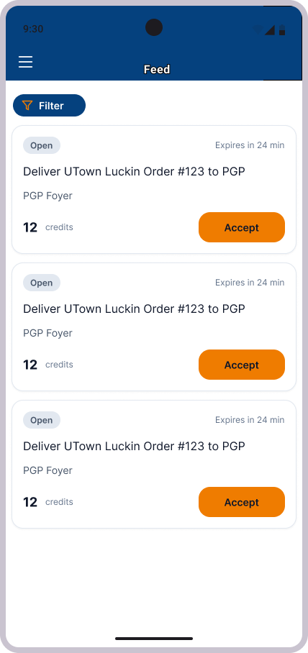
Fig 3. Screen for viewing all available requests

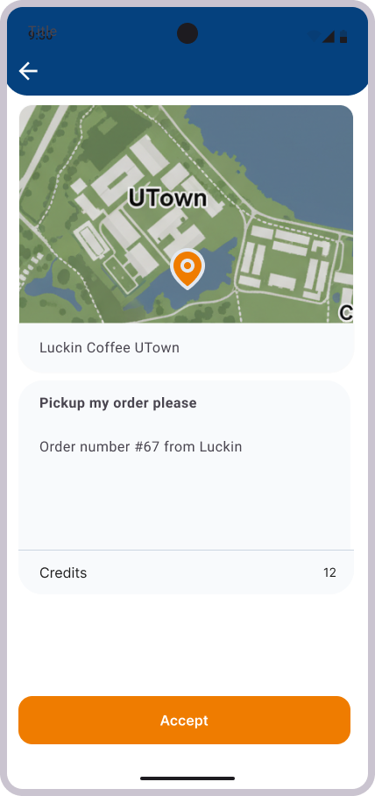 | 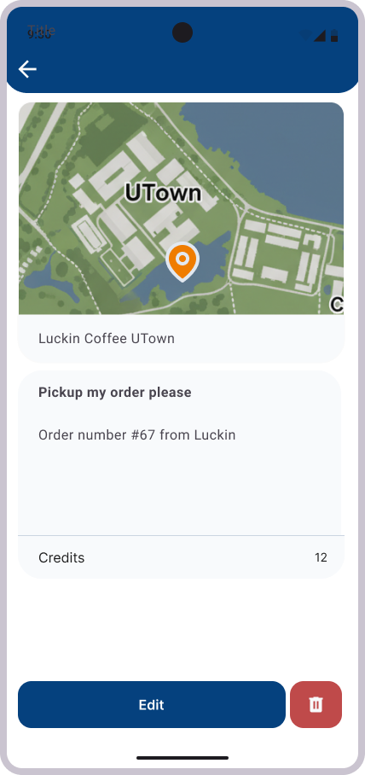
Fig 4. Screen for viewing a specific request | Fig 5. Screen for viewing a user’s own request

Requester
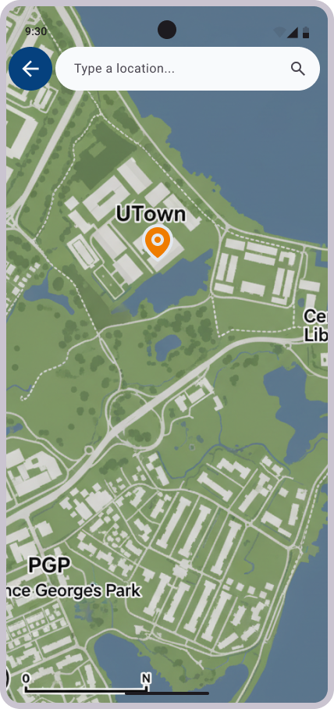 | 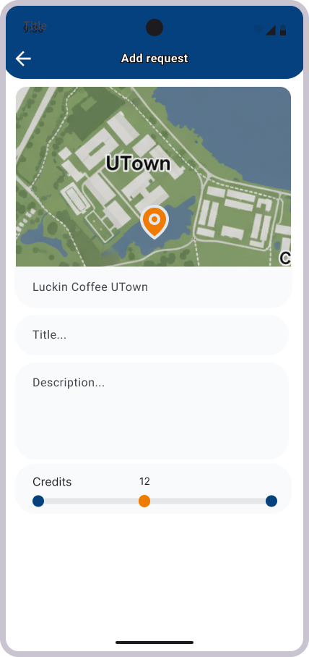
Fig 6. Screens for making a request
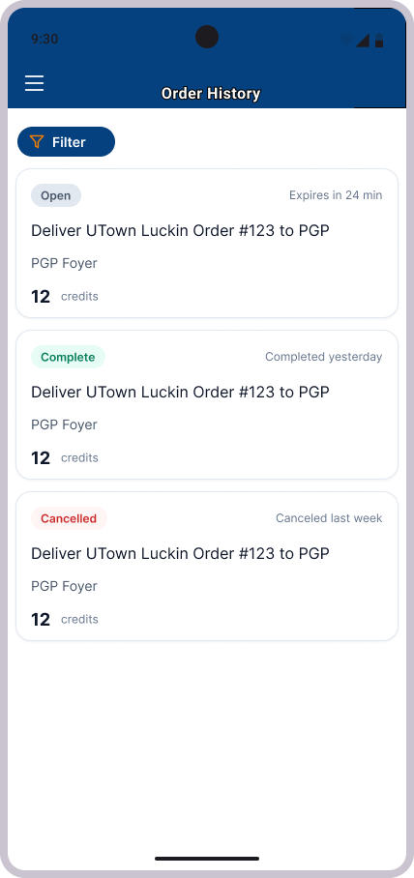
Fig 7. Order history of a user’s past requests

